OUR MISSION
AAUW advances equity for women and girls through advocacy, education, philanthropy and research.
OUR VISION
AAUW empowers all women and girls to reach their highest potential.
OUR PHILANTHROPY
+ Yearly scholarships for graduates from Monona Grove High School and LaFollette High School;
+ The Odyssey Project at UW-Madison for students who need a program of support and compassion to start college;
+ Several scholarships for UW-Madison students.
+Scholarship for a young woman to attend the National Conference for College Women Student Leaders (NCCWSL); and
+ The National AAUW Greatest Needs Fund, which supports education, leadership, legal advocacy, and pay equity for women.

OUR FUNDRAISING
+Road trips to visit museums, see plays or enjoy docent-led historical sites. Profits support our scholarships.
+A Used Book Sale usually held the third Saturday and Sunday in September. This is a great way to recycle books for a worthy cause.
+A Silent Auction each December that features new and white elephant items, jewelry, handmade treasures and much more.
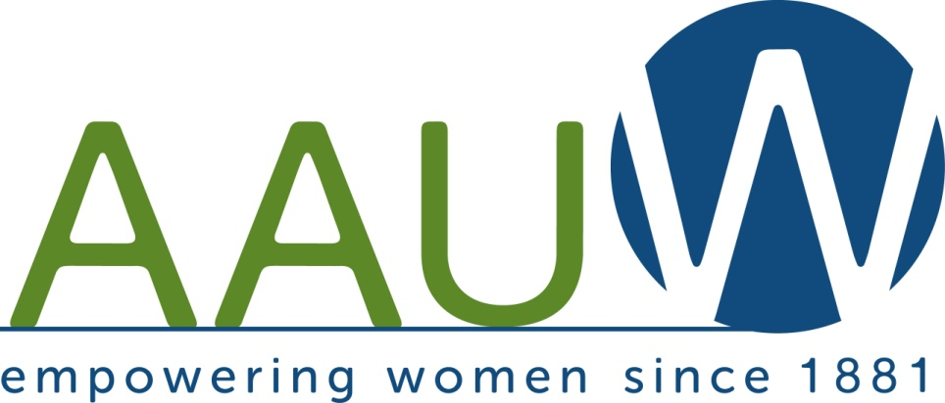
Monona/Madison
Branch
We welcome members and guests from all surrounding communities.
The American Association of University Women (AAUW), founded in 1881, is open to all graduates who hold an associate degree or a baccalaureate or higher degree from a regionally accredited college or university. The purpose of AAUW is to advance equity for women and girls through advocacy, education, philanthropy, and research.

AAUW is a non-partisan, non-profit organization with over 170,000 members nationally, 100’s of local branches, and 800 partnerships with colleges and universities.
AAUW values and seeks a diverse membership. There shall be no barriers to full participation in this organization based on gender, race, creed, age, sexual orientation, national origin, disability or class.
If you are interested in joining or would like more information, visit
www.monona-madison-wi.aauw.net
General Meetings
Live meetings with a hybrid option will take place at the Odyssey Center (Room 22) at 2238 South Park Street in the UW South Madison Partnership Building behind the Madison Public Library—Goodman Library except for the Holiday Luncheon. Both January and February meetings will be ZOOM only. There are NO water fountains in the building! All members/guests must bring their own beverage for all meetings.
General Meeting Programs
For 2023
September 26-—6:00 p.m. Potluck Supper. Members A-M: bring main dish or salad to serve 8-10. Members N-Z: please contribute $10. Speakers: Carol Salinas, Janesville AAUW STEM Coordinator and Pat Phillips, State AAUW STEM Coordinator. Title: ‘Tech Savvy Programs’

October.24—6:30 p.m. Social time
7:00 p.m. Speaker: Jennifer Uphuff Gray, Artistic Director of Forward Theater Company. Title: ‘Make Live Theater Your Healthy Habit”

November 28--6:30 p.m. Social time
7:00 p.m. Speaker: Kristina Gumez, M.A., Library and Information Studies; Community Engagement Librarian, Madison Public Library; Intellectual Freedom Chair, Wisconsin Library Association. Title: ‘Unite Against Book Bans: Standing Together in the Fight Against Censorship Habit’

December 2—Holiday Luncheon and Live/Silent Auction at Maple Bluff Country Club. Auction begins at 11:15 a.m. and Luncheon is served at 12:00 noon. Speakers: Monona/Madison Nominees to.AAUW’s National Conference for College Women Student Leaders (NCCWSL)

General Meeting Programs
For 2024

January 23--ZOOM 6:30 p.m. Social time
7:00 p.m. Speaker: Francine Hirsch, PhD., Vilas Distinguished Achievement Professor of History, UW-Madison. Title: ‘Russia’s War on Ukraine’

February 27—ZOOM 6:30 p.m. Social Time 7:00 p.m. Speaker: Kim Simes, Chief of Staff—Family Equality. Title: ‘Love, Family, Freedom. It Really is That Simple’

March 26—6:30 p.m. Social time and Girl’s Biz students will present their program.
7:00 p.m. Speaker: Luke Sprague, Oral Historian, Wisconsin Veterans Museum. Title: ‘Wisconsin Veterans Tell Their Stories’

April 23—Salad Supper. 6:00 p.m. Members N-Z: bring a salad or main dish to serve 8-10. Members A-M: please contribute $10.
7:00 p.m. Speaker: Carolotta Calmese, a former Dean at Madison College and a pastor of Madison’s Fountain of Life Church
Title: ‘Spirituality in African American Communities’

May 28—6:30 p.m. Social time
7:00 p.m. Speaker: Mary Murrell, PhD Anthropology, a Branch member and writer of the award-winning Monona Bird Report on Monona community radio 98.7
FM WVMO, The Voice of Monona Title: ‘The Wonder of Bird Migration’

June 1— Picnic at Tower Hill Park, 5610 Cheryl Drive, Fitchburg,

Interest Groups

Anyone who is a member of AAUW is welcome to attend any of the following interest groups. Please call the hostess if you plan to attend. Refreshments are served at the discretion of the hostess.

Literature Groups

The Morning Literature Group meets at 9:30 a.m. on the fourth Thursday of most months at the Monona Library.

The Evening Book Group meets at 7:00 p.m. on the third Wednesday of the month in the homes of the members. A planning meeting is held at Barnes and Noble in May for the upcoming year.

Lunch Book Bunch

The Lunch Book Bunch meets from 11 a.m. to 1 p.m. once a month at a coffee shop/restaurant to socialize and discuss favorite books on a given topic.

Great Decisions

Great Decisions is a discussion group based on the Foreign Policy Association’s Great Decisions book for 2023. There are eight meetings per year starting in late January or early February.

La Cuisine
La Cuisine members plan and prepare gourmet dinners. Members may invite a spouse or guest to each dinner. Dinners typically start at 6:30 p.m.

Film Group
The film group meets on the second Tuesday of the month. Usually, a film is chosen on Friday and members are notified of the movie, time and place by e-mail.

Bridge Marathon
The Bridge Marathon is a fundraiser for the branch. Partners play once a month through May. Everyone gets together to play on a Tuesday in May at the Monona Community Center.

